**Mawlana Bhashani Science and Technology University**





**Lab-Report**

Report No:05

Course code: ICT-4202

Course title: Wireless and Mobile Communication Lab

Date of Performance:18.09.20

Date of Submission:25.09.20

**Submitted by Submitted To**

Nazrul Islam

Assistant Professor

Dept. of ICT

MBSTU.

Name: Amrita kamkar

ID:IT-14060

4th year 2ndsemester

Session: 2013-2014

Dept. of ICT

MBSTU.

**Experiment No:05**

**Experiment Name:** Comparative Analysis of Wired and Wireless data using Wireshark

**Objectives:** Wireshark is a network traffic analyzer which is also an essential tool for any security professional or systems administrator. In the previous lab the basic things about wireshark has been discussed. In this lab what we are going to do is to compare the traffic capturing using both the wire and wireless data.

**Theoretical Explanation:** Wireshark is a network packet analyzer as a measuring device for examining what’s happening inside a cable. For wired data capturing the USB cable, the direct line from the router can be used an associative support for packet capturing.For wireless the wifi, ethernet both are widely used

**Working Procedure for capturing Data packets:** There are some steps that to be followed in this lab**.** First of all I open the wireshark menu bar.

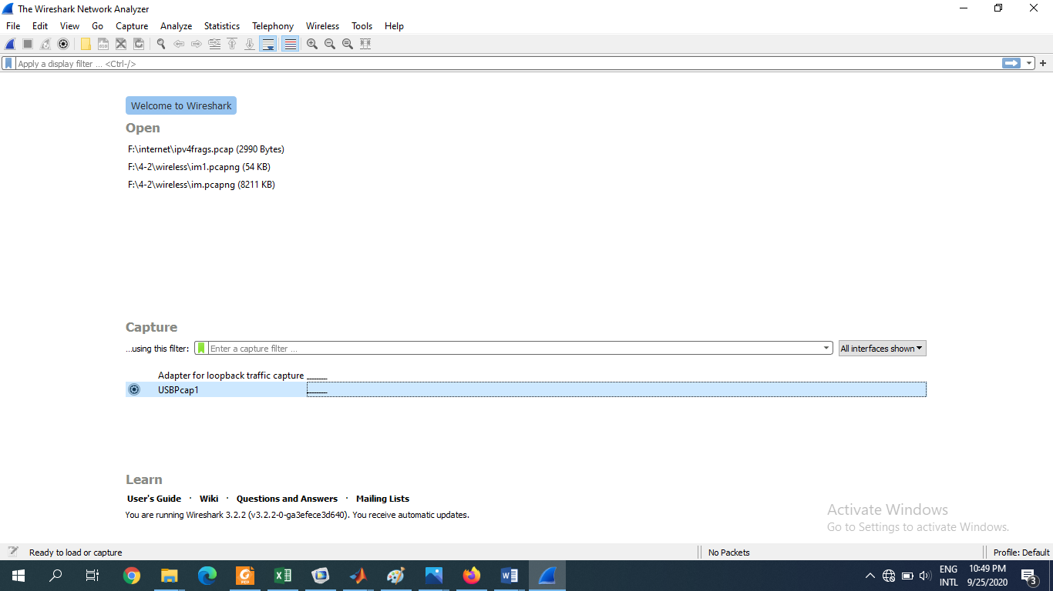

**Fig1:Openning the menu bar for wireshark**

For wireless capturing there are some options could be seen

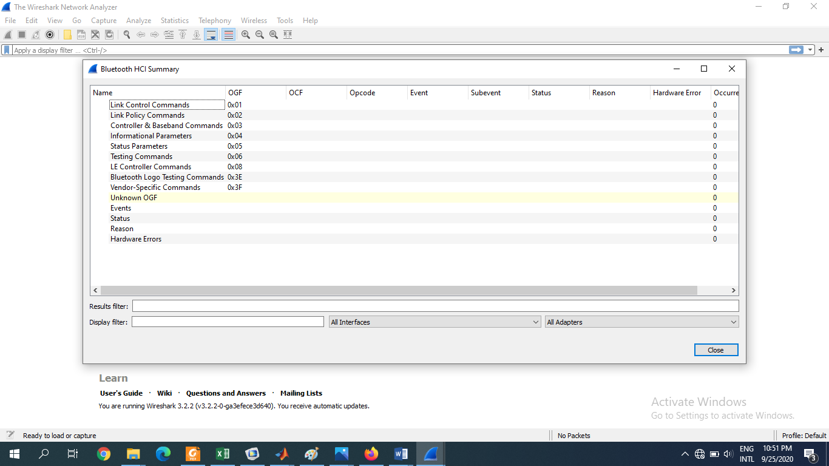

**Fig2:selecting wireless to capture filters**

There would be some networks from where I need to select the one I want to capture on

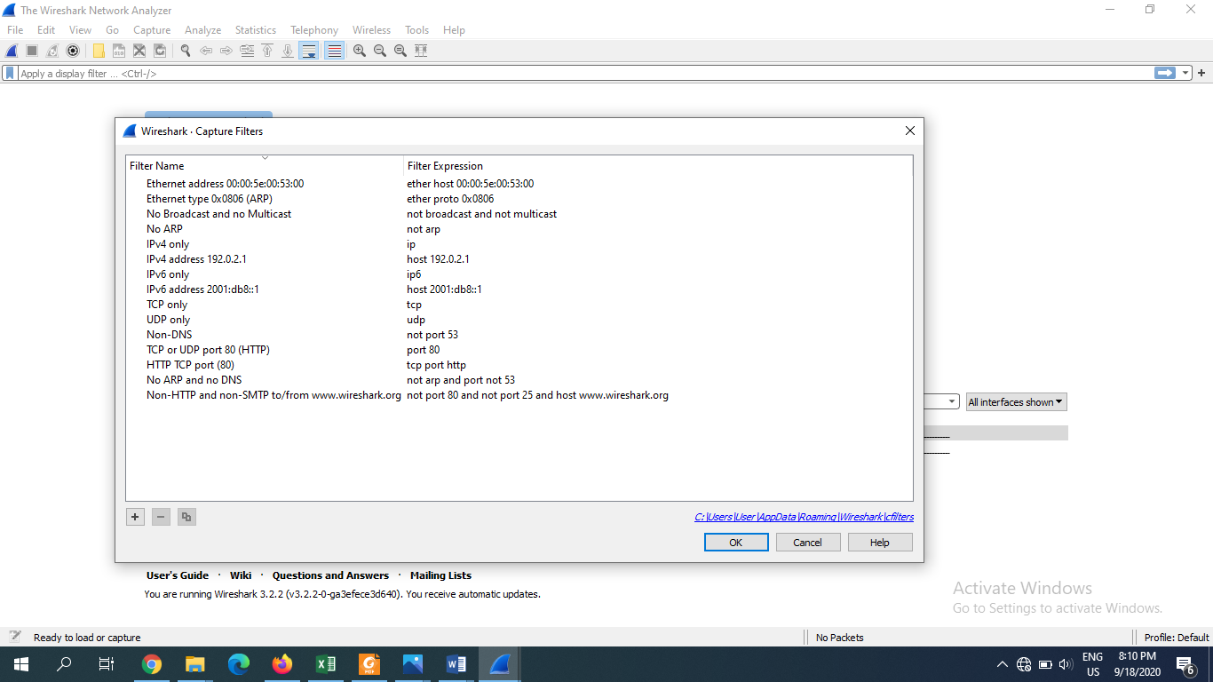

**Fig3:selecting the network**

I selected the ethernet

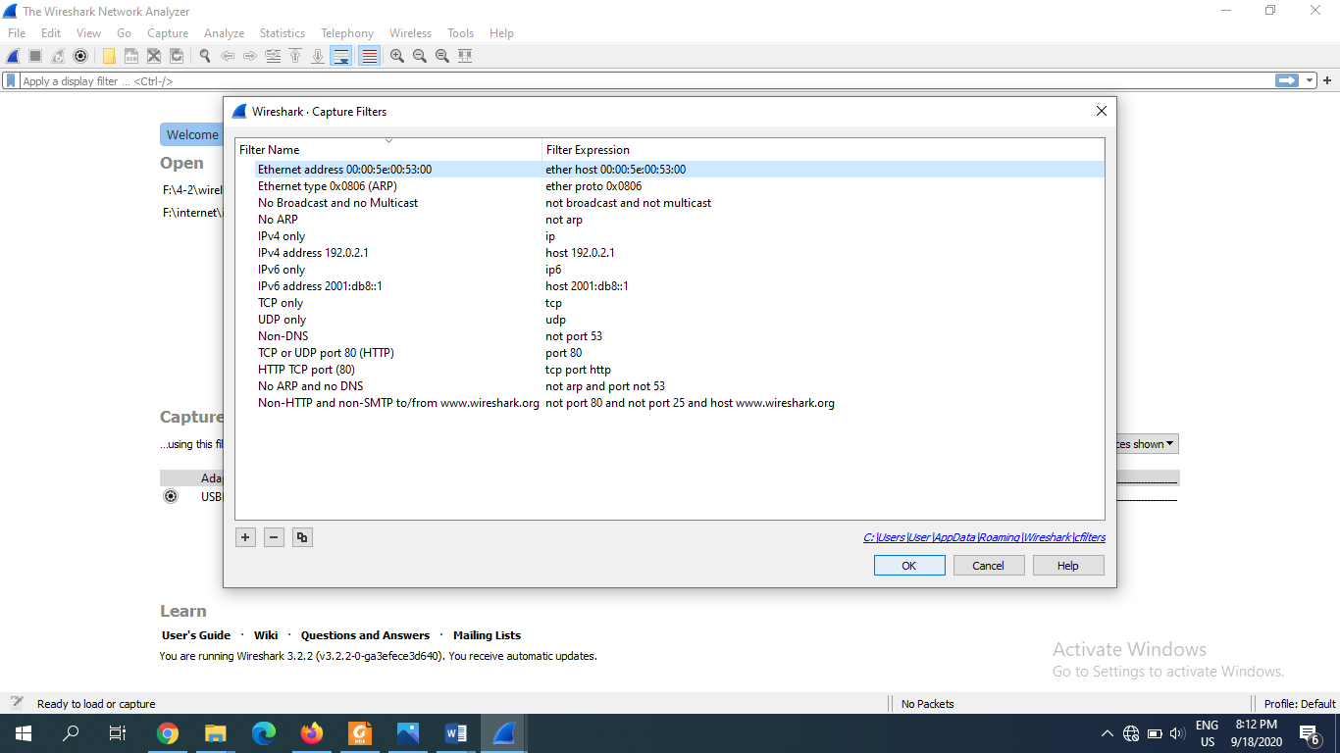

**Fig4: selecting the ethernet network**

This is how the capture starts on

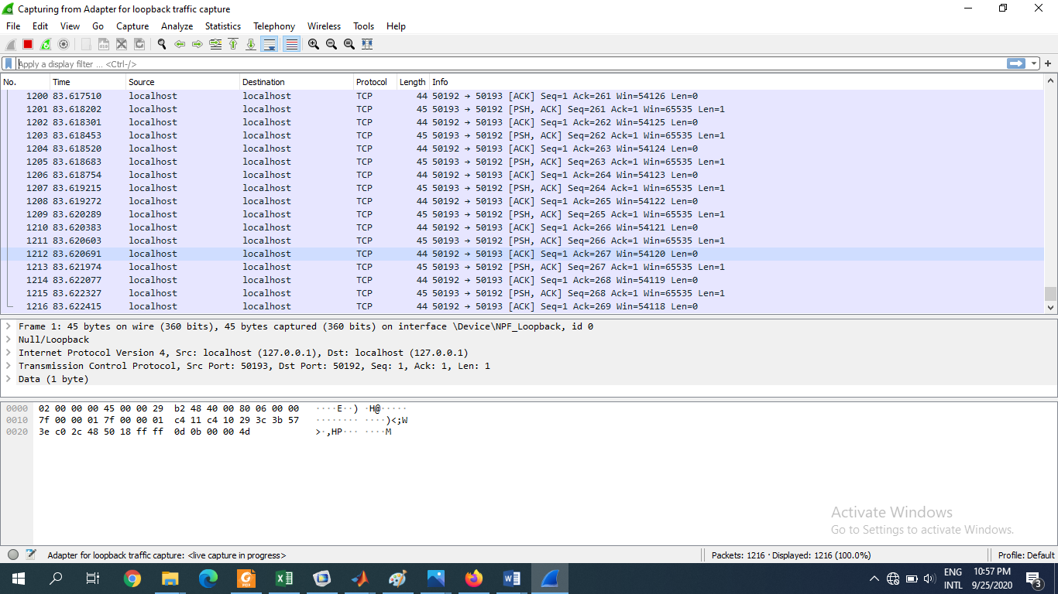

**Fig5:started to capture capturing(wireless)**

The capturing can be stopped by clicking the stop

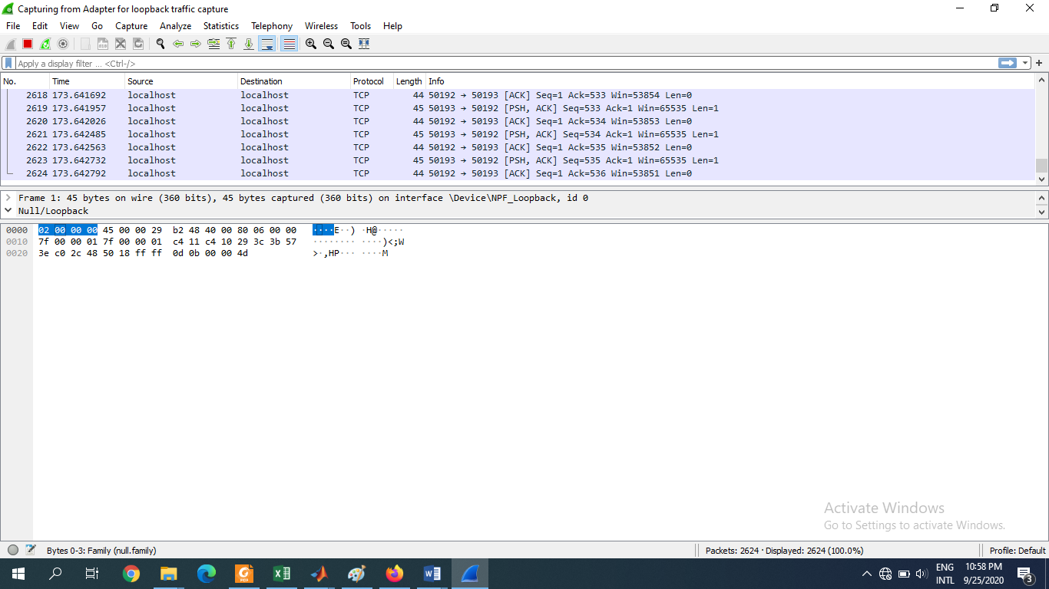

**Fig6:stopping the capture(wireless)**

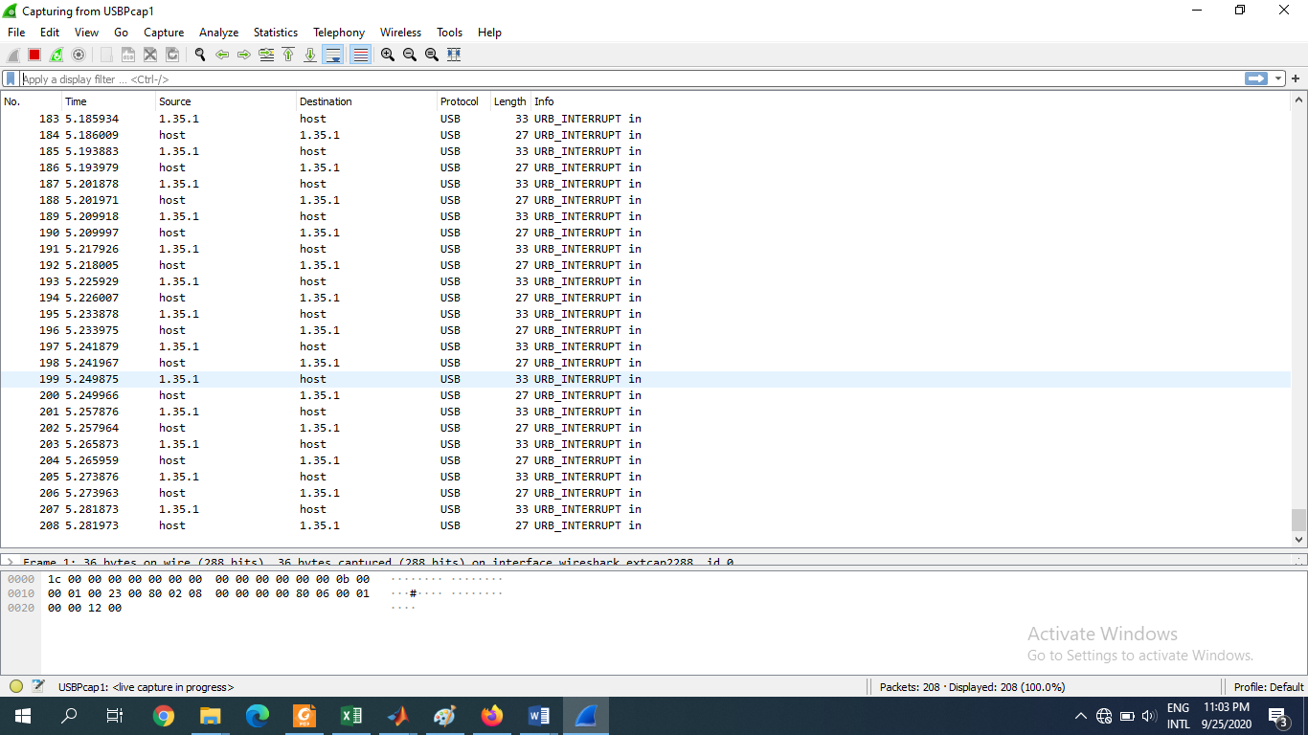

**Fig7:The way data packet capturing traffics(wired)**

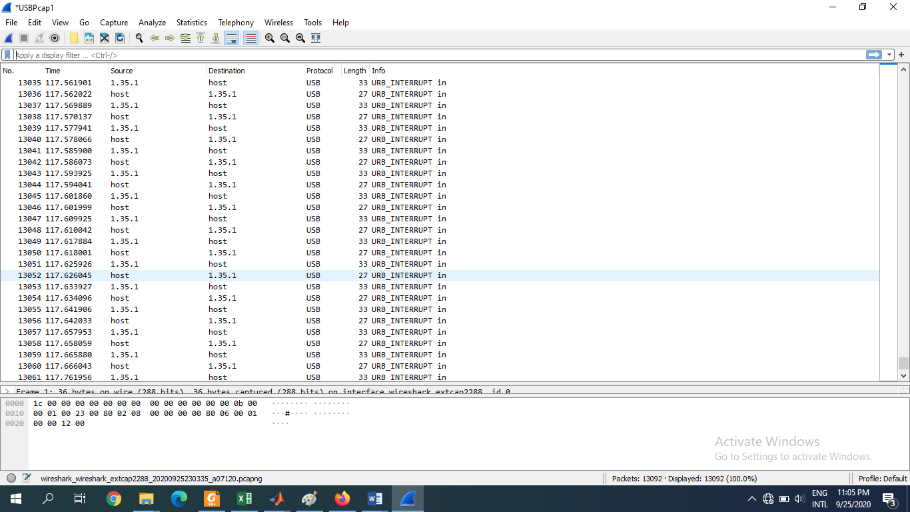

**Fig8:stopping the capture(wired)**

Packet bytes consists of Hex,ASCII and offset fields.

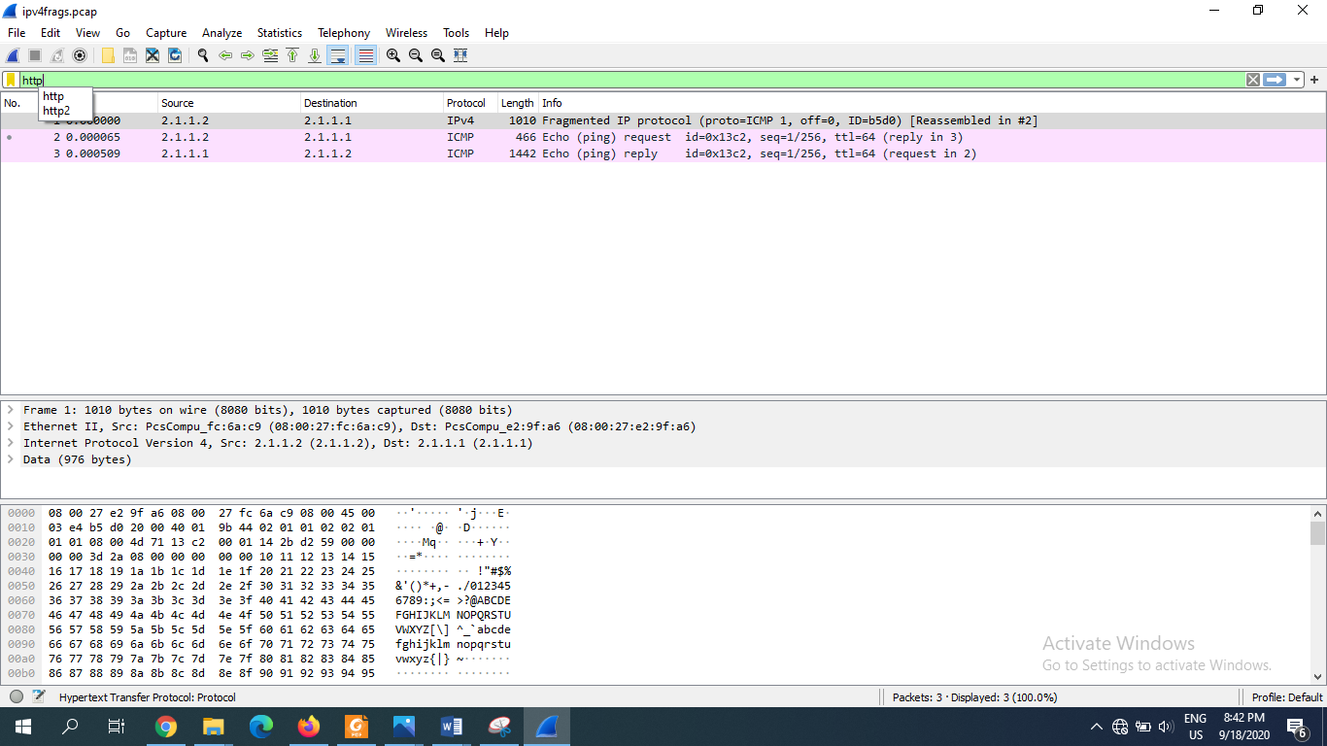

**Fig9:packet details for pane segment**

To see the traffic flow, there are some options in statistics is then needed to select.

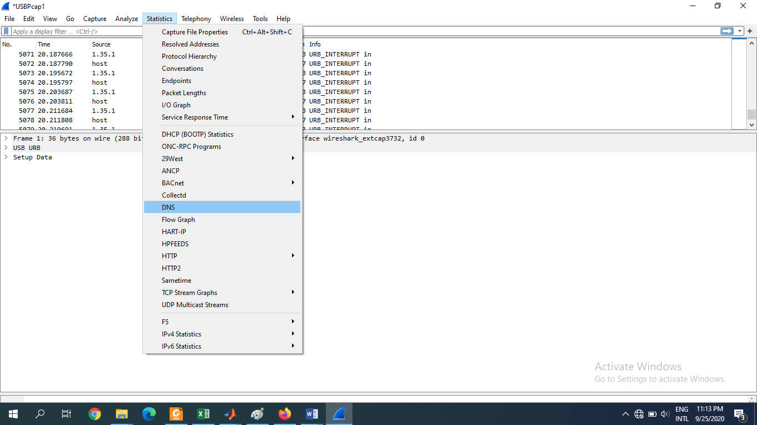

**Fig10:statistics options**

Selecting the DNS-

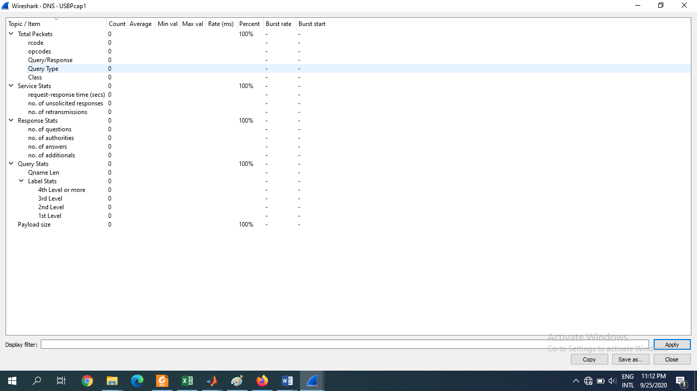

**Fig9:DNS statistics for pane segment**

Then the statistics is change into flow graph flow is for all flow.

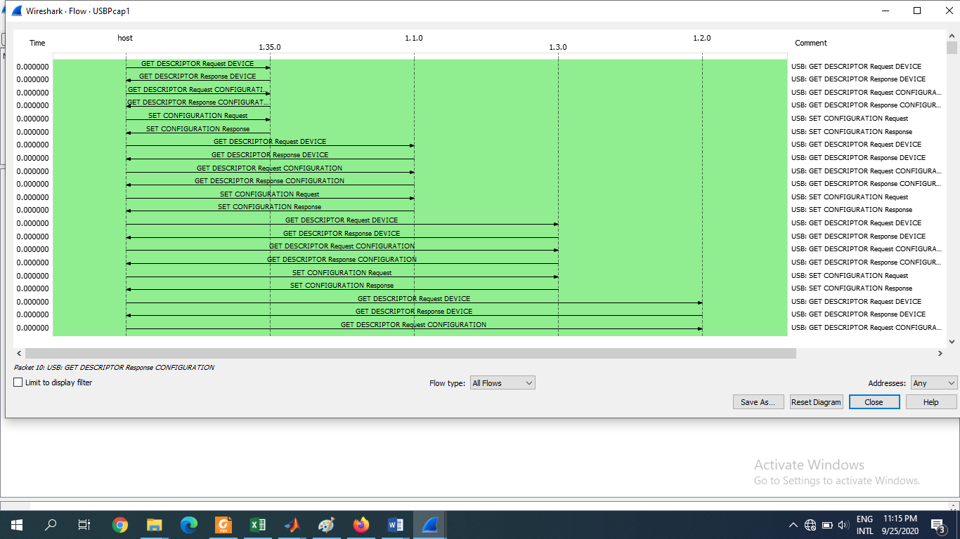

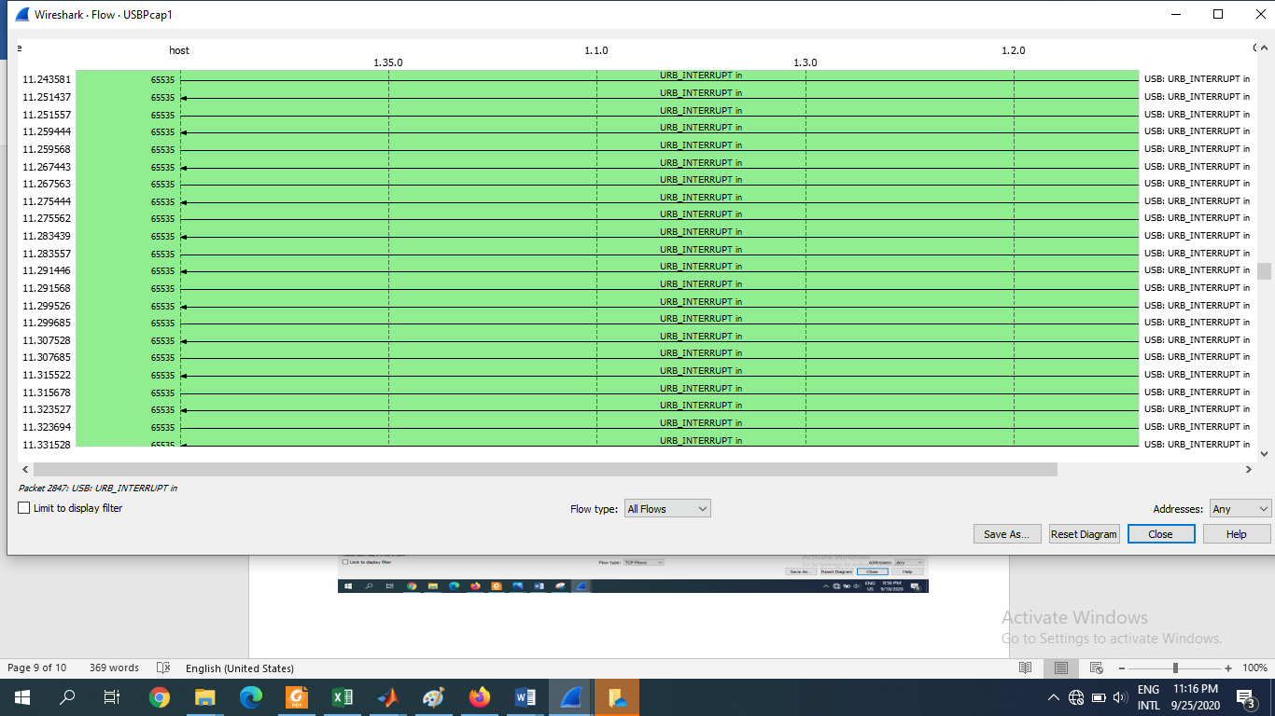

**Fig10: Graph of all flow statistics**

**Discussion:** This lab, is a forward step after the previous lab. In this lab we tried to compare the data traffic for both the wired and wireless network. This lab work give us the preciseness of working with the wired and wireless network using wireshark.